Übung Subnetting

Berechne Subnetz für 192.168.85.170/24:

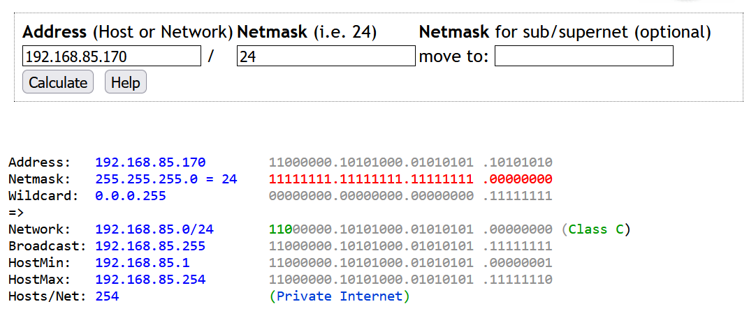

Berechne Subnetz für 192.168.85.170/25:

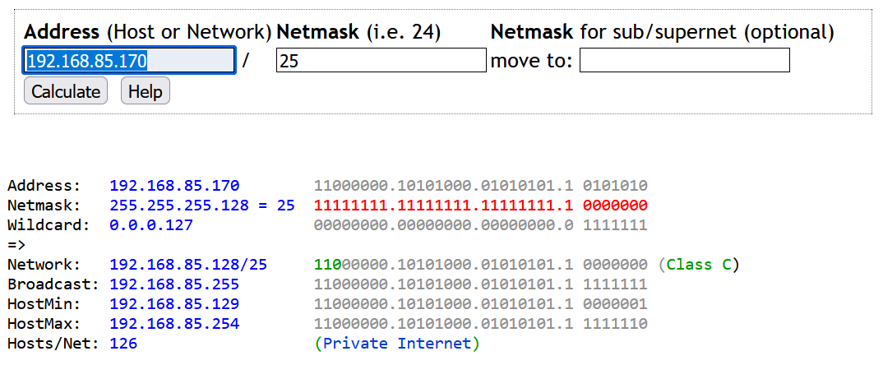

Berechne Subnetz für 192.168.85.170/26:

|  |  |  |
| --- | --- | --- |
| Address |  |  |
| Netmask |  |  |
| Wildcard |  |  |
| Network |  |  |
| Broadcast |  |  |
| HostMin |  |  |
| HostMax |  |  |
| Anzahl Hosts |  |  |

Berechne Subnetz für 192.168.85.170/27:

|  |  |  |
| --- | --- | --- |
| Address |  |  |
| Netmask |  |  |
| Wildcard |  |  |
| Network |  |  |
| Broadcast |  |  |
| HostMin |  |  |
| HostMax |  |  |
| Anzahl Hosts |  |  |